**Alpha Car Hire Car Rental Portal Management System**

# **Section 2.0 Project Deliverables**

## **Time, Cost and constraints**

Every equipment that makes up the Alpha car Hire Car Rental Portal Management System always seems to be evolving. This would be intended for customers who've been renting cars from the shop. These improvements make the process of renting a car more convenient generally. Everyone who wishes to rent a car can benefit from this strategy since it is extremely cross-platform. Every user must set up a free account in order to utilize online Alpha car Hire Car Rental Portal Management System and become a customer. The client would then be offered the option to sign up for the website irrespective before they became a client. This web-based program appears to be going through the formative stages right now. Expenditures, wider implications, as well as other criteria are adequately considered (Rogers, Pawlik and Shwom, 2015). This customized version to have been starting, although it is currently in the planning process. The fact that this process continues to be in very early stages shows that so many proposals have really only simply received approval, although the initial phase already has begun. The website is designed to have the possibility of developing into an established business automated website after the bulk of surveillance and improvement have been completed.

The project may take a little while for completion of the overall system of Alpha car Hire Car Rental Portal Management System. Below given is the Gantt chart for the project completion of this system.

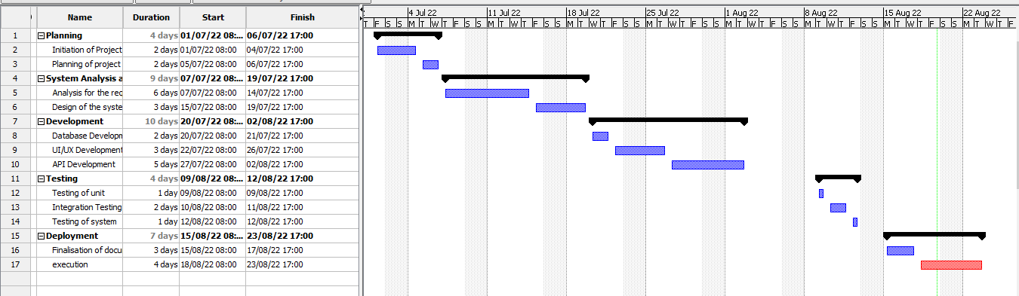

Despite not having any guarantee that they would be necessary, such initial costs are already in fact a fundamental element of the creation of every system. The overall expense associated with this type of technique ought to always be anticipated in addition to assessed. According with this specific initiative, general payment schedule is provided by offering involvement in order to obtain financial support. The associated anticipated costs may aid others in estimating the amount of cash one will actually really have to finish developing every such system. Here, is the budget estimation for Alpha car Hire Car Rental Portal Management System:

|  |  |
| --- | --- |
| Task | Required Budget |
| Planning for the project | $10,000 |
| Analysis of the project | $15,000 |
| Designing of the project | $30,000 |
| Implementation of the project | $35,000 |
| Testing performance | $20,000 |
| Review and maintenance | $10,000 |
| Total | $1,20,000 |

## **WBS**

This diagram above shows the parts that make up various responsibilities. Projects are straightforward to assign and to accomplish attributable to innovation. For organizing the objective as well as perform the job, this would be helpful. This Work Breakdown Structure (WBS), one of the most commonly used construction project papers, appears to be an additional method which thus implements one such technique across initiatives (Indelicato, 2009). Planning, cost, and a portion of such system design being coordination and collaboration throughout this way, guaranteeing that projects are currently on schedule.

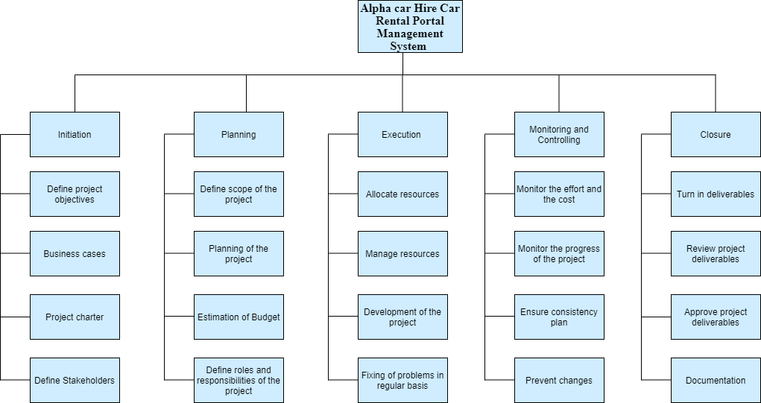

# **Section 3.0 System Requirements**

The technical specifications appear to represent the specs that outline the capabilities and the way the software components. Given that its framework has been currently under developed, it appears that even these software and hardware are already being adequately taken into account. Every platform's needs are broken down into two categories which are covered in detail mostly in platform standards' subcategories all across the computer system design (Chitchyan and Bird, 2022). In fact, the platform's non-functional and functional criteria constitute its prerequisites. The system requirements for this system are as follows:

* Whenever an individual arrives the website, users all arrive at the identical page.
* Every user will be directed to their personalized profile which allows them to perform a range of tasks following successfully authenticating with the proper login and password.
* This user interface would be straightforward and consistent, utilizing language that the system's potential audience are likely to understand. The system will include an easy-to-use interface that adheres to industry standards, obviating the requirement need occasional users' user training.
* Additional hardware connections are not required.
* This system will employ use of customary equipment as well as information-transfer capabilities.

# **Section 10.0 Entity-Relationship Diagram**

The Entity Relationship Diagram (ERD) seems to be a diagram that displays the relationships between various components in such a system. Relational database architecture uses them extensively. Entities from the ER schema are transformed into records, characteristics, as well as the database schema (Al-Masree, 2015). They are frequently used mostly for data administration also because they can be employed to display database schema including associated relationships (ANISAH MOHD SAAD and MUNIANDI, 2020).

Here, the system's ERD is shown in the table below. The users, employees, clients, booking, automobile, and payment are the entities in this system. The client and booking demonstrate a one-to-many interaction where the customer makes the booking and the car is reserved. Following the completion of the car reservation process, the customer makes payment. Every entity has a variety of properties.

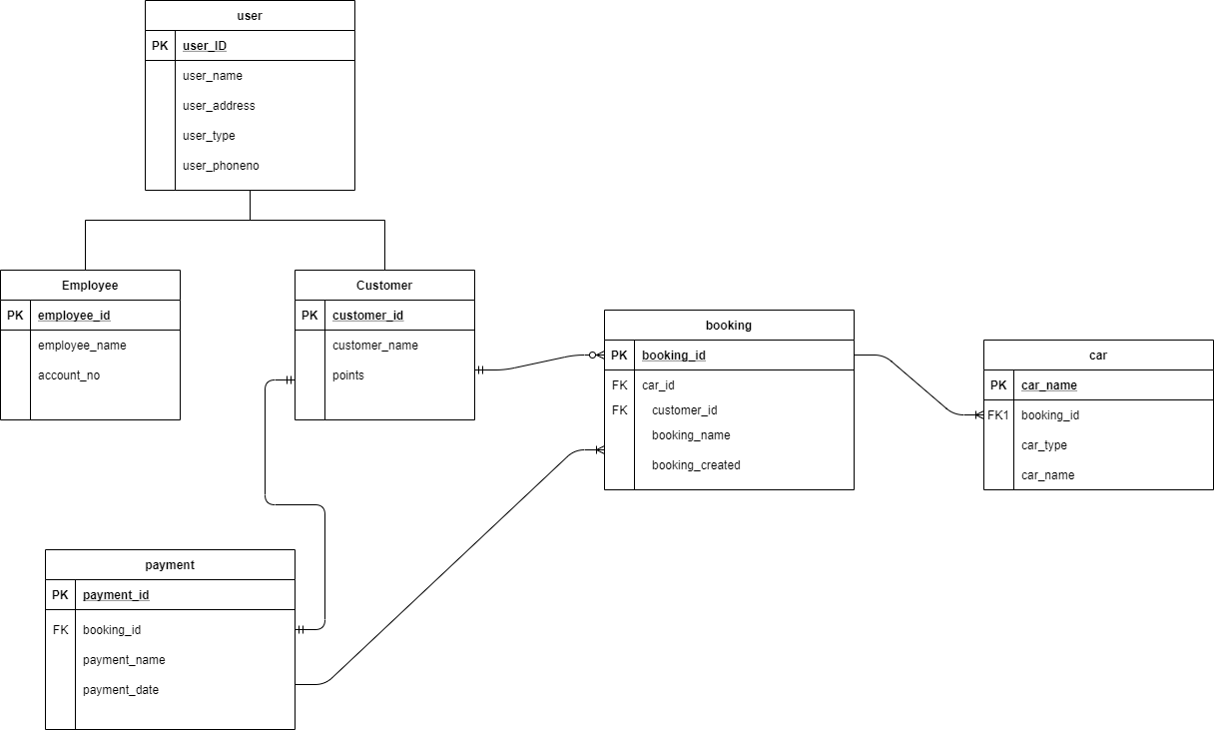

# **Section 11.0 Data Dictionary**

* User record

|  |  |  |  |
| --- | --- | --- | --- |
| Name of field | Size | Data Type | Description |
| user_id | 15 | int | User_id can be considered as the primary key for the database table user. |
| User_phoneNo | 255 | varchar | Name of the user |
| user_name | 255 | varchar | Phone no of the user. |
| user_address | 255 | varchar | Address of the user |
| user_type | 255 | varchar | Type of the user |

* Customer record

|  |  |  |  |
| --- | --- | --- | --- |
| Name of the field | Size | Data Type | Description |
| customer_id | 15 | int | customer_id can be considered as the primary key for the database table user. |
| points | 15 | double | Name of customer |

* Employee record

|  |  |  |  |
| --- | --- | --- | --- |
| Name of the field | Size | Data Type | Description |
| employee_id | 15 | int | employee_id can be considered as the primary key for the database table user. |
| name | 255 | varchar | Name of the employee |
| account_no | 255 | varchar | Account no of employee where their salary goes. |

* Car record

|  |  |  |  |
| --- | --- | --- | --- |
| Name of the field | Size | Data Type | Description |
| Car_Id | 15 | int | car_id can be considered as the primary key for the database table user. |
| Customer_id | 255 | varchar | Foreign key with reference to customer table in database. |
| Car_number | 255 | varchar | Number of the car. |
| Car_Type | 255 | varchar | Type of the car. |

* Booking Record

|  |  |  |  |
| --- | --- | --- | --- |
| Name of the field | Size | Data Type | Description |
| Booking_id | 15 | int | booking_id can be considered as the primary key for the database table user. |
| Customer_id | 15 | int | Foreign key with reference to customer table in database. |
| booking_Name | 255 | varchar | The name booking is made in. |
| car_id | 15 | int | Foreign key with reference to car table in database. |
| Booking_created |  | bool | For the confirmation of booking. |

* Payment record

|  |  |  |  |
| --- | --- | --- | --- |
| Name of the field | Size | Data Type | Description |
| payment_id | 15 | int | payment_id can be considered as the primary key for the database table user. |
| payment_name | 255 | varchar | The name payment is done with. |
| payment_date |  | date | Date when the payment was done. |
| Booking_id | 15 | int | Foreign key with reference to booking table in database. |

# **References**

1. Al-Masree, H 2015, ‘Extracting Entity Relationship Diagram (ERD) From Relational Database Schem’ *International Journal of Database Theory and Application*, vol. 8, no.3, pp.15-26.
2. ANISAH MOHD SAAD, N. and MUNIANDI, M 2020, ‘The Reflections on the using of Oracle Data Modeler in Creating Entity Relationship Diagram (ERD)’, *International Journal of Research Publications*, 66(1).
3. Chitchyan, R. and Bird, C 2022, ‘Theory as a source of software and system requirements’ Requirements *Engineering*, vol. 27, no. 3, pp.375-398.
4. Indelicato, G 2009, ‘Book Review: Building a Project Work Breakdown Structure: Visualizing Objectives, Deliverables, Activities, and Schedules’, *Project Management Journal,* vol. 40, no.3, pp.85-85.
5. Mahmoud, A. and Williams, G 2016, ‘Detecting, classifying, and tracing non-functional software requirements’ *Requirements Engineering*, vol.21, no.3, pp.357-381.
6. Rogers, P., Pawlik, L. and Shwom, B 2015, ‘The Role of Deliverables in Project Work’, *SSRN Electronic Journal*.